Cyda’s Special Christmas

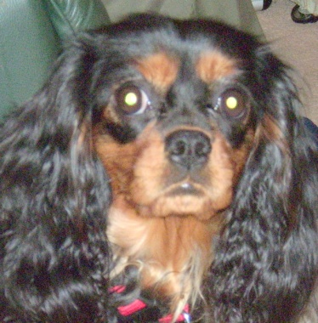
Hello, my name is Cyda.

I’m very special because when all my brothers and sisters went to their new homes, Mummy Anne let me stay here.

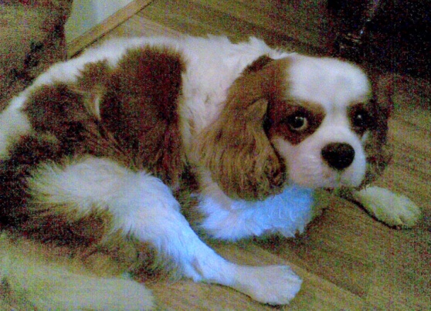
Last Christmas my Mummy Anne brought Uncle Toby and his Grandpa Manny up for a Special Christmas.
We had such fun!
Uncle Toby is my special friend.
I was sad when Uncle Toby had to go back home.

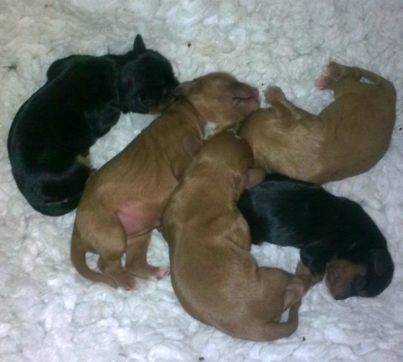
I was growing up, and I noticed that I was getting fatter ... and fatter ... and fatter!
I grew ... and I grew ... and I grew!
Then one day I started having babies.
One baby ... Two babies ... Three babies ... Four babies ... Five babies!
What a surprise!
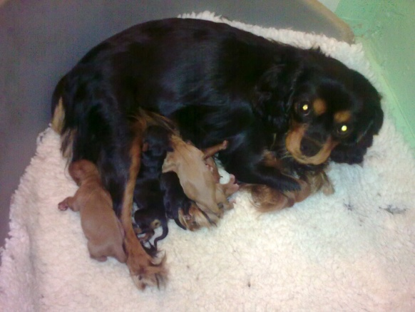
Mummy Anne made a nice warm bed for us.
She gave me some really yummy dinner.
I ate all my dinner.
My babies snuggled up to me.
We all snuggled up together and went to sleep.

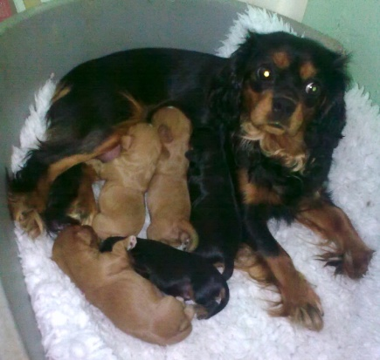
The next morning my babies were still there!
One baby ... Two babies ... Three babies ... Four babies ... Five babies!
So I fed them and washed them and loved them.
My babies snuggled up to me.
We all snuggled up together and went to sleep.

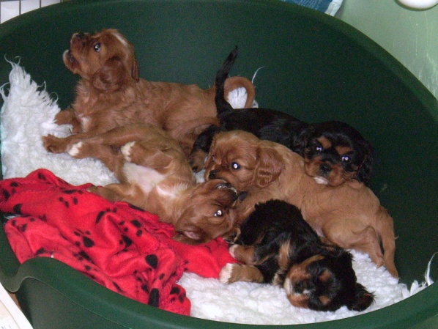
Soon, my babies started to grow.
They grew ... and they grew ... and they grew!
Soon they were big enough to open their eyes and see!
I could see them and they could see me.
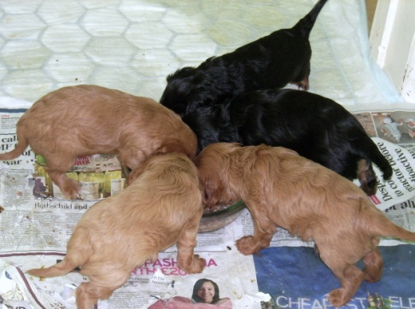
Mummy Anne gave them some really yummy dinner.
They ate all their dinner ...
And they grew ...
and they grew ...
and they grew!

Soon they were big enough to have names.
Harvey and Olive and Sox and Rosie and Skully.

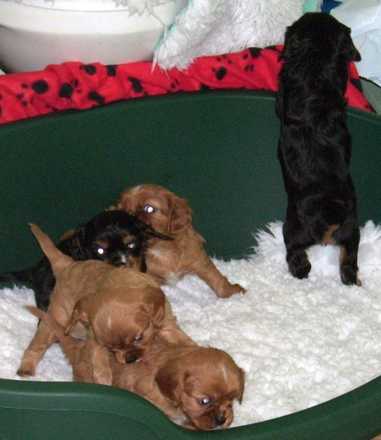
My babies learned how to walk.

They walked ...
and they walked ...
and they walked

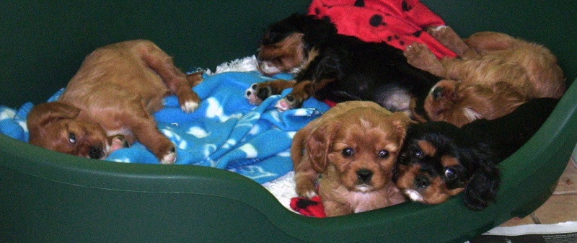

Then they snuggled down in their bed and went to sleep.

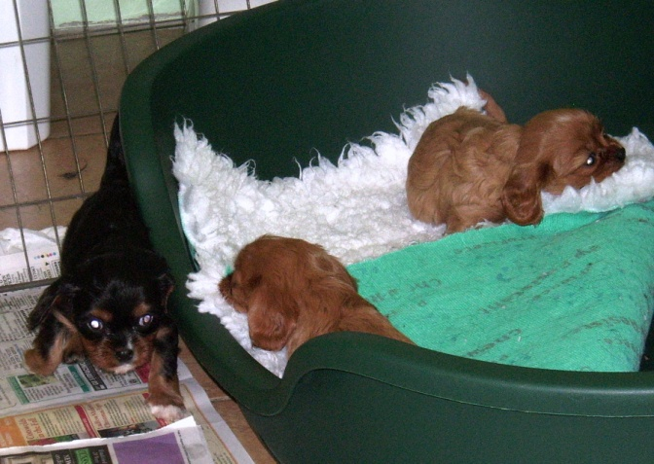

They learned how to tug their blankets around to make a nice soft bed.

Some of my babies did a dance for the camera. See them here:
httpv://www.youtube.com/watch?v=7vHXGKjlGi8
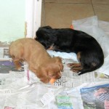

Mummy Anne gives us yummy carrot sticks sometimes.
We like yummy carrot sticks.
We ate up all our yummy carrot sticks.

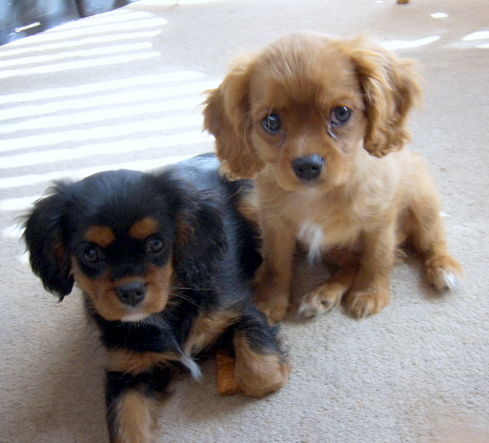

Here is Skully with her brother Harvey.

